Issue 12
January 2022

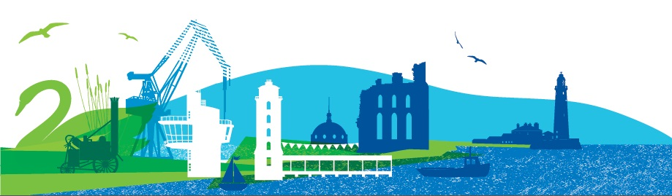
Patient Forum Bulletin
For Practice Patient Groups in North Tyneside
Welcome to the latest edition of the Patient Forum Bulletin in which we update GP Practice Patient Groups about what’s happening in the Forum. The COVID-19 Pandemic continues to impact on us and the way we work and we continue to meet by video using Microsoft Teams for both Forum meetings and for our working groups too. This will continue until deemed safe to resume face to face meetings.
Patient Forum Meeting 6th January 2022
The Patient Forum met on 6th January using Microsoft Teams and were joined by Marc Rice from the CCG, Wendy Burke, Director of Public Health for North Tyneside and Dr Jason Scott and Kate Byrnes from Northumbria University. We were also joined by a representative from Ponteland PPG who was welcomed as an observer.

Working Groups Information
The Working Group briefing accompanies this Bulletin providing information on work plans and progress. There will be a Development Session in June to consider the formation of the groups and how they align with place-based work.

CCG update
Marc Rice from NHS North Tyneside CCG gave an update:

Integrated Care System (ICS)
The CCG will now continue until the end of June following the delay, organisational change is underway.
Primary and secondary care
Marc confirmed at the time of this meeting, there is currently up to a 25% sickness rate, and this does impact on service delivery, there is also a 50% Covid outbreak in care homes.
Omicron variant
Members asked about the Omicron variant and Wendy Burke advised that before Christmas the rate of infection was around 450 per 100 thousand and now (as at 6th January) is 2400 per 100 thousand. This does confirm post-Christmas the increase is substantial and predominantly in younger age people, especially those not vaccinated. That said there is also an increase in the over 65s. Out of the 31 care homes in North Tyneside 25 have reported an outbreak and it does seem this is more about staff infection rather than residents. This equates to around 100 staff and 20 plus residents. The variant is not causing severe illness for most people therefore people are not being admitted to hospital, this is also resulting in fewer deaths. Despite the figures it is an improving picture in North Tyneside and being three weeks behind London in trends which has already peaked, and the NHS being two weeks behind the infection rate, does mean the next five weeks will be difficult.

Wendy Burke Director of Public Health North Tyneside
Health and Wellbeing Strategy/Inequalities Strategy
Wendy gave a presentation which detailed the strategy which is underpinned by three key pieces of work:
- Impact of COVID-19 pandemic on health and socio-economic inequalities in North Tyneside, October 2021.
- Summary of the evidence base to tackle health inequalities, October 2021.
- Joint Strategic Needs Assessment (JSNA), October 2021.

Wendy advised that there is a slowing of life expectancy and in North Tyneside this means a baby born now in Riverside Ward can expect a life expectancy of 11.7 years of life less than a baby boy born in Tynemouth, less than four miles away. Data shows from around 59-60 years old people are going into retirement in poor health.
Residents least likely to cope with the pandemic in terms of income, social isolation and lock-downs have been hit the hardest.
The strategy has been developed with a range of stakeholders and goes on to highlight where we want to get to. Working with communities has been invaluable and they raised education and skills, social networks and income as important factors. There are three strategic ambitions; equal life chances for all, thriving places and communities and maintaining independence. The focus will be on the four areas likely to have the biggest impact.
The best start in life, enabling all children, young people and adults to maximise their capabilities and have control over their lives, creating fair employment and good work for all, ensuring a healthy standard of living for all, places and communities we live in and with, lifestyles and health behaviours and finally an integrated health and care system.
The health inequalities grant is available again for community groups to support this work.
The next step in the strategy is to turn it into an action plan and this should be ready by April.
A copy of the presentation accompanies this Bulletin.

Dr Jason Scott and Kate Byrnes– Northumbria University
SafeST Care Homes research update
Jason advised that because of changes in the research staff the study has been extended. We were updated on both work streams and the presentations accompany this Bulletin.

Keep up to date with progress by visiting the website; https://research.northumbria.ac.uk/SafeST

Useful Links
www.northtynesideccg.nhs.uk/
www.healthwatchnorthtyneside.co.uk
www.ageuk.org.uk/northtyneside
www.voda.org.uk
www.nhs.uk/coronavirus
www.gov.uk/coronavirus
my.northtyneside.gov.uk/category/1429/coronavirus-covid-19
www.northtynesidecarers.org.uk

