

**Issue 27**

**June 2022**

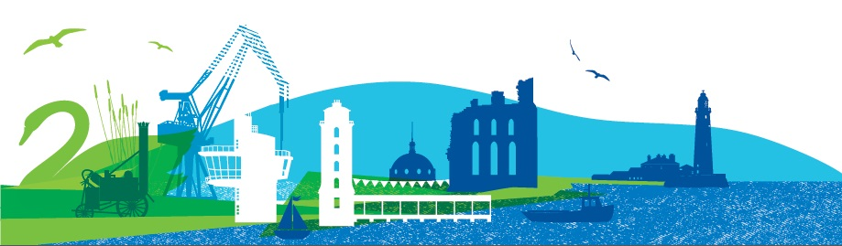

In this Issue

Celebration of nurses, day

Covid-19 update

COVID Contemplation

COVID stories

Patient Forum Working Groups Achievements

Discover me

Shared Decision Making

Can you identify this?

Health Inequalities Fund

Tyne & Wear Fire and Rescue Service

Coping with Cancer

Family Ambassador CNTW

Help me be digital

North Tyneside Carers Centre

Did You identify?

Message from the Chair

**Patient Forum Newsletter**

Welcome to the latest Patient Forum Newsletter. We have many items of news and updates which we hope will be useful to you.

**North Tyneside**

**Celebration of nurses day**

North Tyneside held its own celebration of nurses day on Thursday 12 May at The Parks in North Shields.

Past and present nurses attended the celebration which was hosted by Wendy Burke, Director of Public Health and Norma Redfearn, North Tyneside's elected Mayor.

Patient Forum member and retired nurse Pat Bottrill, pictured with the Mayor, gave a presentation on the day to attendees on the theme of kindness, caring and compassion, both to patients and to peers, using examples from her career and retirement.

**Coronavirus (COVID-19)**

**For NHS information please click** [**here**](http://www.nhs.uk/coronavirus)

**For Government guidelines please click** [**here**](https://www.gov.uk/coronavirus)

**For local information please click** [**here**](https://my.northtyneside.gov.uk/category/1429/coronavirus-covid-19)

**COVID Contemplation**

Five lasting memorial areas are being created across North Tyneside to help people to remember and reflect upon the impact of the coronavirus pandemic.

Connected to the borough’s 30-mile wagonway network, the areas of reflection are places where people can visit to remember the loved ones that they tragically lost during the pandemic, as well as offering a space to reflect on the impact the pandemic had on us all and remember the ways in which people came together to support one another. All of the reflection areas are based around the theme of a compass, detailed in decorative hard landscaped paving, with seating provided and natural planting, as places to sit and reflect.

The artwork in the centre of the compass is unique to the location where it is situated and has been chosen with help from local communities.

Work is underway to create the other areas and they will be opened within the coming weeks. The locations and associated artwork include:

* Silverlink Biodiversity Park – sundial design
* Killingworth Lakeside Park – George Stephenson design
* Redburn Dene Park (North Shields) – fishing design
* Souter Park (Whitley Bay) – lighthouse design
* Wallsend Hall grounds – shipbuilding design

**Explore the COVID stories of**

**North Tyneside residents**

Helix Arts has been working on stories and artworks, follow this link for more information.

#### <https://www.helixarts.com/news/explore-the-stories-of-north-tyneside-residents/>

**Patient Forum and Working Groups Achievements**

The Patient Forum was established during 2014 and a number of working groups and task and finish groups were set up. Each has its own workplan and members have worked tirelessly for the benefit of patients through many service changes, new initiatives and campaigns. Eleanor Hayward has chaired the Forum from the beginning, and senior CCG staff have chaired the other groups and guided members through policies and initiatives. Everything from the Keep Calm campaign to changes in urgent care have been influenced by members.

A sincere thank you is due for all of the members both past and present for their continued commitment and dedication over many years.

Marc Rice at the CCG has created this video showcasing the range of involvement from 2014-2022.

You can view the video on this link <https://youtu.be/gnD0sMUr6Y0>

**New name for the Discovery College**

#### DiscoverMe posterThe Discovery College has some exciting news! We have been busy brainstorming lots of ideas for a new name with our fantastic volunteers. The young people voted that they liked the “Discovery” part of the name but not the “college” part as felt it didn’t really fit in with the service that is being offered.

#### After lots of discussions, the votes are in! Our new name is DiscoverME #ReinventUs!

#### The thinking behind the name is that the recovery college will be a journey of discovery where they will find out new things about themselves and learn new skills.

#### We also have a logo in progress so watch this space! Are you 16-25 years old and want to get involved? Head over to our [website and express your interest today](https://voda.us7.list-manage.com/track/click?u=0e8d7e0b002ddaa4791d984c9&id=6dea127f3f&e=cdf36b72ed).

**Shared Decision Making**

To help patients make the most of their appointment with a health professional, North Tyneside CCG, with input from the Patient Forum, have produced a video. As well as advice on preparing for appointments, the video highlights the benefits of shared decision making to support patients to make decisions about their care and treatment.  Patients are encouraged to think about what is important to them regarding their treatment and discuss it with their clinician. The video will be shown on GP practice waiting room information screens and can be previewed here

<https://www.youtube.com/watch?v=TblGO-Nh_VQ>

**Can you identify this local landmark?**

Find the answer on page 8.

**Health Inequalities Fund**

From peer support groups for people suffering with arthritis to cycling support for children and families, voluntary sector organisations are beginning an important programme of work to help tackle health inequalities across North Tyneside.  
  
A new Health Inequalities Grant Programme, developed by members of the Better Together group, has awarded grants of between £10,000 and £30,000 to fourteen Voluntary, Community and Social Enterprise (VCSE) sector organisations.   
  
Funding has been provided by North Tyneside CCG and North Tyneside Council, with the grant programme being administered by VODA. All funded activities focus on delivering outcomes relating to the key themes of the recently published Equally Well strategy for North Tyneside - ‘Equal life chances for all’, ‘Thriving places and communities’ and ‘Maintaining independence’.  
  
The grants programme aims to be more than just an offer of funding. In order to build an evidence base of what works and to help identify scalable solutions, all successful applicants will attend six-monthly learning and development sessions delivered in partnership with Goodlabs- a local management consultancy that helps charitable organisations to enhance their social impact. [Read more here](https://voda.us7.list-manage.com/track/click?u=0e8d7e0b002ddaa4791d984c9&id=78c2e591f6&e=cdf36b72ed) about this programme and some of the work it is funding.

**Tyne & Wear Fire and Rescue Service**

Please follow the link below for more information on this free of charge Safe and Well Check and Falls Prevention service.

<https://www.northtynesideccg.nhs.uk/wp-content/uploads/2022/06/HSC-FallsPreventionFullTyne-A5.pdf?x34242>

**Coping with Cancer**

Coping with Cancer North East has been established since 1982, delivering in 13 different NHS sites across the region. We provide care and support to anyone affected by cancer in the North East of England, including friends, carers, and families of cancer patients.

Our aim is to improve the lives of people affected by cancer in the North East of England. We provide our free counselling, free complementary therapies and free support groups within primary and secondary care, community centres, via phone or video, and at our therapeutic centre in Cramlington. We facilitate and support patient and community groups to ensure that those affected by cancer have the opportunity to be seen, heard, valued, and influence the services that they need.

Our counsellors here at Coping with Cancer offer a warm, supportive, and non-judgmental environment to allow individuals the space to express how they are feeling and reflect on their situation. The counsellors at Coping with Cancer use a person-centred approach, so that the session is led by the client and not directed by the counsellor. The counsellor and the client are equals rather than an expert treating a patient. The client can request to receive their counselling face to face or over the phone.

We also offer free complementary therapies. Complementary therapies do not replace traditional treatments, they can be used alongside them. Here at Coping with Cancer we offer, Reiki, Reflexology, Auricular Acupuncture, Indian Head Massage, Body Massage and Hearts Massage. Our Auricular Acupuncture can be given on a one-to-one basis or in a group setting. We have found a number of our clients find the group sessions a safe space to share their experience with people who are on a similar journey.

Learn more about our services here: <https://copingwithcancer.org.uk/>

Coping with Cancer are here every step of the way, and anyone can access our services by:

📞 **Calling:** 0191 250 2026

📧 **Emailing:** [info@copingwithcancer.org.uk](mailto:info@copingwithcancer.org.uk)

🌐 **Filling out a short form here:** <https://copingwithcancer.org.uk/contact-us/>

**Family Ambassador**

The Family Ambassador role is a new national role that CNTW (Cumbria, Northumberland, Tyne & Wear NHS Foundation Trust) have started to implement. The role was created by a task force, featuring leaders from across the NHS, other key partners, and parents and carers with lived experience of their loved one being admitted to a mental health facility. The role was designed specifically to support the families of the child. They are there to provide help and support for parents and carers, so that they can understand and navigate the processes around their child’s care whilst they are in hospital. Health Education England have created some animations to explain this role in more detail. These videos can be found via the below links.

<https://youtube.com/playlist?list=PLrVQaAxyJE3dZ4BfCQcqwdhlxPYLxNqcx>

<https://www.e-lfh.org.uk/?p=20866&post_type=programes&preview=1&_ppp=47c0224777>

**Help me be digital drop in sessions**

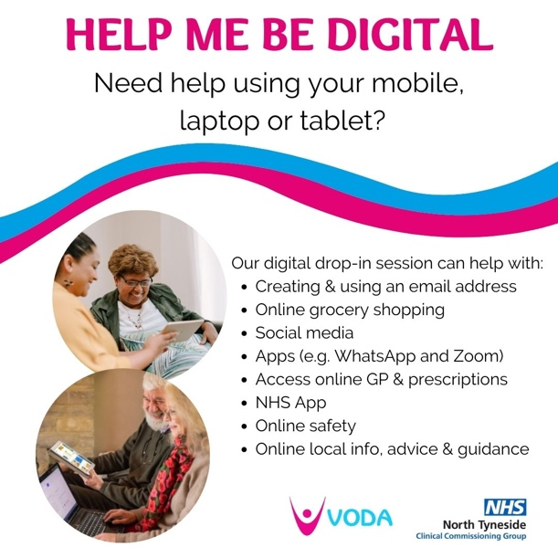Many local residents have access to a smart phone, laptop or tablet, but are unable to use their devices for what they need. We believe that with increased support to access digital equipment, connectivity, and skills, our residents can live happier and healthier lives.  
  
With this in mind, the [Help me be Digital Project](https://voda.us7.list-manage.com/track/click?u=0e8d7e0b002ddaa4791d984c9&id=ad5ea881ef&e=cdf36b72ed) hosts digital drop in sessions around the North Tyneside Borough. At the drop-in sessions residents can come in with their digital device and ask for help on a range of topics, from creating an email address to using online prescription services.  
  
**Current sessions:**

* Every Monday: 1.30pm to 3pm at Dreamshine Well-Bee-Ing Hub. 84 Park Road, Wallsend NE28 6Q
* Every Tuesday: 11am to 1pm at St Columba’s United Reformed Church. 30 Northumberland Pl, North Shields NE30 1PW
* Thursday 9 June: 11am to 1pm YMCA North Tyneside Church Way, North Shields NE29 0AB

**North Tyneside Carers Centre**

**Who cares for the carer?**

North Tyneside Carers’ Centre provides support, advice and information to unpaid carers.

We are holding a Gong Bath (meditate and bathe in the healing vibrations of sound) on 26th July, at the Scout Head Quarters on Norfolk Street, North Shields at 6:30 if you would like any further information or book your free place please contact the Carers’ Centre on 0191 643 2298 or emailing [enquiries@ntcarers.co.uk](mailto:enquiries@ntcarers.co.uk)

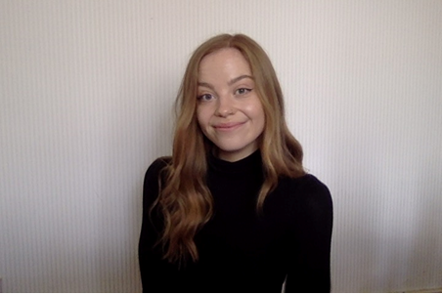**Meet Lucy our Carers Into Work Advisor**

I am so excited to start my position as the Carers Into Work Advisor at North Tyneside Carers’ Centre (NTCC).

My role is attached to the Carers into Work Project which is overseen by the North of Tyne Combined Authority. NTCC is working with Newcastle Carers, and Carers Northumberland. The project aims to provide flexible support to carers from the age of 16. We will work with carers one step at a time, to help them to achieve their potential through a range of interventions.

These interventions can include one to one coaching, addressing any barriers into work, boosting employability skills, and matching carers with potential employers.

We can also support carers with understanding their rights at work, so they can flourish in their career.

If you are a carer who is struggling in work **or** struggling to find work, please contact me on 0191 643 2281.

Website: [www.northtynesidecarers.org.uk](http://www.northtynesidecarers.org.uk)

Email: [enquiries@ntcarers.co.uk](mailto:enquiries@ntcarers.co.uk)

I will be happy to help!

**Did you identify this?**

Whitley Bay Lighthouse

**Eleanor Hayward**

**Chair of the Patient Forum**

And finally…it has been my pleasure to chair the Patient Forum over the last eight years. NHS North Tyneside Clinical Commissioning Group comes to a close following a national restructure. From the 1st July 2022 North Tyneside will be part of the newly formed Integrated Care System and more information can be found here: <https://www.england.nhs.uk/integratedcare/what-is-integrated-care/>.

The Patient Forum will continue, albeit under a new name, however the emphasis will continue to be; influencing services for the benefit of residents, and you will see from the Reflections video linked on page four the range of services and initiatives members have been actively involved with. This is my opportunity to thank members past and present for their commitment and dedication to our local NHS, and also to thank the talented and hard working staff within the CCG and Michele Spencer at CHCF.

**This newsletter has been produced quarterly by members of the CCG Patient Forum Communications Working Group and will continue under a new name.**

**If you like the sound of the Patient Forum and would be interested in being part of it please contact; Michele Spencer** [**michele@chcfnorthtyneside.org.uk**](mailto:michele@chcfnorthtyneside.org.uk) **for more information**