Issue 3
March 2023
North Tyneside Patient Forum Newsletter
In this Issue
Covid-19 update
Sun Awareness Week
Can you identify this?
Deaf Awareness North East
Warm space in Cullercoats
Tyne & Wear Fire & Rescue Service Home safety checks
Health Inequalities Fund
North Tyneside Carers Centre
Did You identify?
Member profile
Patient Forum Highlights

Welcome to the latest issue.

Keep up to date with latest local news
Twitter: @NHSNorthTyne
Facebook: NHS North Tyneside
Website: https://northeastnorthcumbria.nhs.uk/
Website: https://nenc-northtyneside.icb.nhs.uk/
YouTube: https://www.youtube.com/channel/UCBrlByVBprLY3x9ob3ct2nw/videos

Coronavirus (COVID-19)
For NHS information https://www.nhs.uk/conditions/coronavirus-covid-19/
For Government guidelines
https://www.gov.uk/coronavirus
For local information https://my.northtyneside.gov.uk/category/1429/coronavirus-covid-19

Sun Awareness Week
Sun Awareness is the British Association of Dermatologists’ annual campaign to raise awareness of skin cancer. The campaign runs from April to September annually and includes Sun Awareness Week 1-7 May.

The campaign is two-pronged and combines prevention and detection advice. The first aim is to encourage people to regularly self-examine for skin cancer. The second is to teach people about the dangers of sunburn and excessive tanning, and to discourage people from using sun beds, in light of the associated risks of skin cancer.

More information can be found https://www.skinhealthinfo.org.uk/sun-awareness/sun-awareness-week/
Can you identify this regional landmark?

Find the answer on page 7.

Deaf Awareness North East
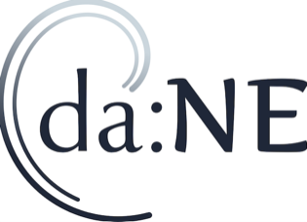
Here at deaf awareness: NE we are passionate about the inclusion of all deaf and hard of hearing people at all times.

There are a few thoughts and ideas that our members and staff team like to keep us aware of so that such inclusion can happen.

The first is that not every deaf person can sign and not all deaf people make good lipreaders, so find out as best you can the communication preference of the deaf or hard of hearing person before conversation.

Get the deaf person’s attention before you begin any communication and reduce any background noise, keeping unnecessary distractions to a minimum.

Make sure you are at an appropriate level and angle so that the deaf person can see your lip patterns, and this will allow the deaf person to pick up any other clues from facial expressions (such as a smile).

Be sure that the lighting is appropriate, not too bright and not too dark, it helps too not to do things such as stand by windows that can cast shadows.

Speaking too quickly or too slowly tends to distort lip patterns, as does eating food, chewing gum or smoking while talking. If the deaf person says you’re talking too fast, then you’re talking too fast.

Maintain good eye contact, use natural facial expressions, and keep your body language natural and confident.

Make it clear when a topic has changed, you could even say ‘new topic’ if that seems appropriate; and use plain language without jargon or abbreviations - Get to the point.

Many deaf and hard of hearing people choose to bluff, so do be sure that everything has been checked.

It may be obvious to say, but don’t look away while talking, or cover your mouth, or move around, as these all make communication more difficult, as does talking from behind or at a distance.

Try not to talk while someone else is talking, the more voices going, the harder the conversation.

Whatever happens during your communication with a deaf or hard of hearing person, never give up and say ‘It Doesn’t Matter’.

To find out more or to book deaf awareness training for your organisation or club please contact info@deafawarenessne.org.uk

Deaf awareness week is 2-8 May 2023.

Warm Space in Cullercoats
In response to the cost of living crisis and as it is becoming more expensive to heat our homes, Cullercoats Methodist Church is opening its doors from 9am until 12noon each Wednesday. During this time people can come to find a warm, welcoming and safe space to spend a few hours each week.

We will be offering free refreshments and there will be opportunities to chat with other people or just read a book. Anyone can drop in during this time and stay as long as needed whilst open.

You will find Cullercoats Methodist Church on The Broadway, NE30 3LJ.

Other warm spaces are available throughout the borough and details can be found via this North Tyneside Council link https://my.northtyneside.gov.uk/sites/default/files/web-page-related-files/Warm%20welcomes%20master%20copy_0.pdf

A range of financial support information including the energy priority register can be found via this link https://my.northtyneside.gov.uk/category/1655/support-all-residents-including-low-income-households

Tyne and Wear Fire and Rescue Service
Safe and well checks and falls prevention
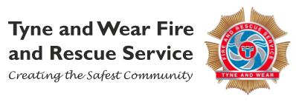
Our safe and well check aims to identify all fire and lifestyle associated hazards, in order to reduce the risk of having a fire or an accident in the home.
Tyne and Wear Fire and Rescue Service personnel deliver various methods of fire safety education and protection advice and will fit appropriate smoke and heat detection, including specialised smoke and heat detection for the deaf and hard of hearing if required.
Education and advice is always tailored and appropriate to the personal needs and circumstances of the occupier in their home. Tyne and Wear Fire and Rescue Service personnel will ensure that all aspects of fire safety and lifestyle risks are covered during the visit, including:
• Fire escape plans
• Bedtime routine
• Kitchen and cooking safety
• Electrical safety
• Smoking safety
• Candle safety
The lifestyle factors the FRS will offer brief advice and onward referral to the most appropriate partners for are smoking cessation, alcohol and substance misuse, dementia, winter warmth, social isolation, hoarding, flu vaccine advice, access to benefits, carers support and crime prevention.
In addition to the safe and well check, primary falls prevention is also offered to all occupiers aged over 60 years. The check aims to deliver advice around falls prevention, covering the following:
• Eye-sight tests
• Medication reviews (discuss how you’re coping with your medication & advise on the importance of medication reviews by your GP/ pharmacist if you’re having problems)
• Slipper check
• Interior lighting
• Good housekeeping/removing clutter
• The importance of strength and balance/exercise classes

Prevention staff also carry out low-level interventions within the home including:
• Securing loose rugs and worn carpets
• Removal of trip hazards
• Securing loose or untidy cables

Issue of non-slip bath-mats, postcard room thermometers, helping hands, replacement ferrules for walking aids and nightlights is also available.

For more information please visit: www.twfire.gov.uk
To request a visit email: pe.tyneside@twfire.gov.uk Or call Freephone 0800 032 7777

Health Inequalities Fund
A charity in North Tyneside is helping older residents overcome loneliness and isolation by sitting down for a chat, a phone call, or even a cup of tea.

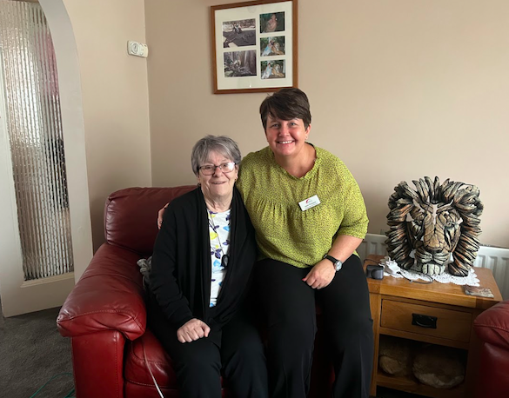
MHA Communities North Tyneside offers telephone and in-person befriending, activity sessions and enablement for residents who need support, or just a friendly face to talk to.

The charity strives to help over 55’s lead fulfilled, active lives, whether that’s by encouraging them to join a lunch club, supporting them in their local community by coming to appointments or popping to their house for a chat. Its volunteers make a big impact on people’s lives.

In June 2022, it received almost £23,000 funding from the Health Inequalities Fund which is hosted by VODA and funded by North Tyneside Council and the NHS North East and North Cumbria Integrated Care Board.

Jackie has benefited from the sessions, she said: “I can’t praise them enough, I look forward to Jayne coming and we sit and put the world to rights together. We talk about everything, our families, the news, whatever comes to our mind.

“I’m so comfortable talking to her, I feel like I’ve been friends with her for years and it’s uncanny because I’m not usually that open with someone.”

This funding is being used to help people who are lonely and isolated and has offered short-term befriending over six weeks to a number of residents.

MHA Communities North Tyneside is recruiting volunteers now. If you’re interested in offering your time to volunteering with the charity, get in touch on 07568 611 991 or visit https://www.mha.org.uk/communities/near-me/north-tyneside/#contact-us

North Tyneside Carers Centre
Positive Vibes
Feeling tired, stressed, low in energy? The Positive Vibes sessions for unpaid carers are here to turn that around and help you get the most out of life. Take the opportunity to find out more about techniques to improve your mental health and relax. The group meets the fourth Thursday of each month in Suite 1 of the Saville Exchange in North Shields which is a warm and comfortable space to share with other carers.

1.00pm- 2.30pm
Suite 1, Saville Exchange,
North Shields, NE30 1SE
To book: Ring: 0191 643 2298 or Email: enquiries@ntcarers.co.uk
Monthly Peer Support Groups for Carers
Meet up with other unpaid carers facing the same situation as you Take the opportunity to share, relax and have a break from caring.

All CARERS’ GROUPS AUTISM CARERS’ GROUP
When: 1st Tuesday of each month When: 3rd Thursday of each month
Next: Tuesday 4 April Next: Thursday 16 March
Time: 2:30 - 4:00pm Time: 6:15pm - 7.45pm
Where: Saville Exchange, Where: Saville Exchange,
Suite 1, Howard Street, Suite 1, Howard Street,
North Shields, NE30 1SE North Shields NE30 1SE

BEREAVED CARERS’ GROUP DEMENTIA CARERS’ GROUP
When: Last Thursday of each month When: 2nd Tuesday of each month
Next: Thursday 30 March Next: Tuesday 14 April
Time: 11:00am - 12:00pm Time: 10:30am - 12:00pm
Where: Whitley Bay Comrades Club, Where: White Swan Centre,
The Links NE26 1PS Killingworth, NE12 6SS

MENTAL HEALTH CARERS’ GROUP
When: Last Thursday of each month
Next: Thursday 30 March
Time: 6:00 - 8:00pm
Where: Saville Exchange,
Suite 1, Howard Street,
North Shields, NE30 1SE

To attend a group for the first time it is best to get in contact first:
Email: enquiries@ntcarers.co.uk
Ring: 0191 643 2298
The Centre also provides free training and information to support unpaid carers in North Tyneside.
For more information or to book use the contact information above.

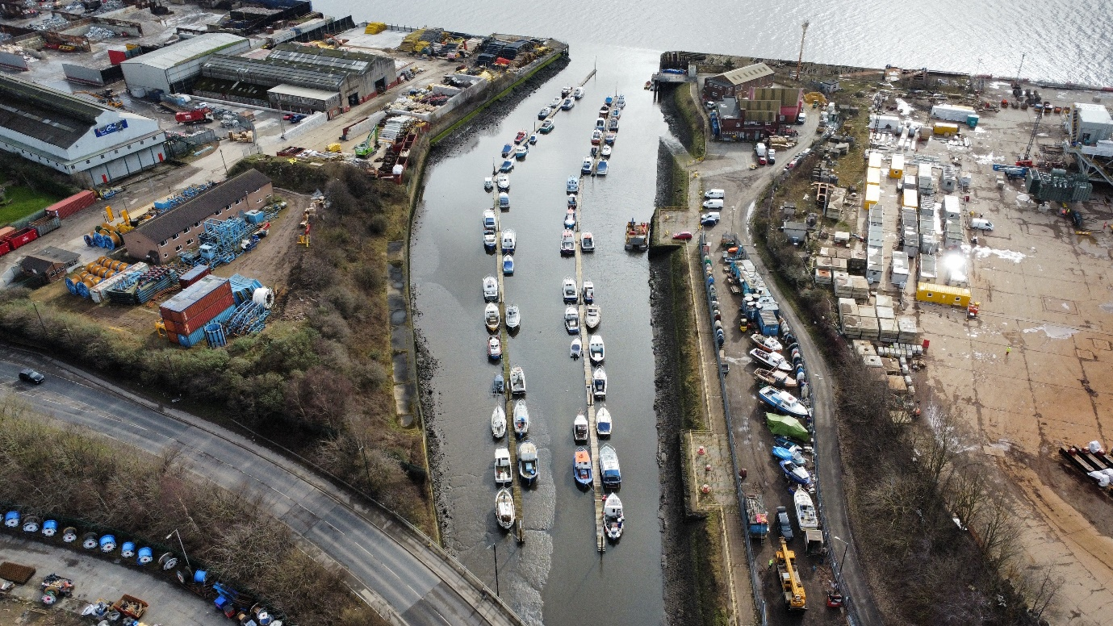
Did you identify this?

Answer: Willington Quay Boating Federation
Thank you to Sam Stephenson for the image.

Member Profile
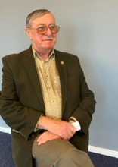
My name is Peter Maitland and I’m 78 and was born in North Tyneside.

About 20 years ago my wife developed a progressive and debilitating medical condition . This proved to be a life changing event for us both and I took early retirement to become her unpaid carer. She had superb support and medical care from our GP practice, consultants and hospitals. My involvement in the Practice Patient Panel and now ICB Patient Forum over the past 20 years is my thanks to the NHS for the care she received.

By qualification I am an Engineer and all of my civilian career was in manufacturing industry. I have in depth management experience in Logistics, Quality Assurance in which I was a Certified Auditor and latterly IT. With my final employer for my last major role I was taken out of my normal function for a year and became a part of a very small UK wide team to replace diverse and site-specific manufacturing IT systems with a common Blue-Chip solution. The critical factor for success was to involve people at every level and all went well on the go live day with only minor glitches.
The Company had a caring attitude towards all employees and was aware of my wife’s complex medical condition which occurred during my service with them and I was offered by mutual agreement voluntary redundancy and early retirement when the above major IT Project ended.

I have always been an outdoors person and keen hill walker and was a Team Leader in a local Walking Club. Now my walking is mainly low level, in my younger days I was also a regular half marathon runner.

I was diagnosed Type 2 Diabetic in my early 50's so changed my diet and the result is now in remission for 10 years but still go for an annual MOT at my GP practice. At age 70 I developed an eye lid cancer, probably caused by my love of the outdoors and trying to keep fit. The speed of reaction from GP concern to consultant referral and treatment was again truly impressive, including old fashioned nursing such as hand holding during surgery.

I am a great believer in the area of innovation within the NHS and patients having ownership of their conditions and treatment plans this in fact was my wife’s experience, not Doctor says you must. I enjoy being a lay member of the ICB Patient Forum which benefits from the diverse wealth of experience from its membership and is not just a box ticking group but achieves real and beneficial improvements for the residents and patients in North Tyneside.

North Tyneside Patient Forum Highlights
NHS North East North Cumbria-North Tyneside Place Patient Forum is strong, robust and acts as a critical friend. Members are encouraged to challenge and debate throughout all engagement processes.

As a constituted group the strength of the Forum is the dedication and commitment within the membership as well as their passion for local health services.
All Working Groups and related topics are decided by Forum Members and are compatible with Strategic Plans and Priorities.

The following reflections video is a compilation of just some of the areas members have had impact and influence on services for North Tyneside residents.
https://youtu.be/gnD0sMUr6Y0

This newsletter has been produced quarterly by members of the North Tyneside Patient Forum Communications Working Group.

If you like the sound of the Patient Forum and would be interested in being part of it please contact; Michele Spencer michele@chcfnorthtyneside.org.uk for more information.

