North Tyneside Patient Forum Newsletter

Issue 4
June 2023

In this Issue
NHS North East & North Cumbria
Covid-19 and booster update
NHS Vaccinations
NHS Screening Programme
Healthier Together
Prescription Prepayment Certificates
Can you identify this?
Ask the Expert End of Life Q&As
Health Inequalities Fund
Mental Health Resources
Did You identify?
Working Well North Tyneside
Patient Forum Highlights

Welcome to the latest issue.

Keep up to date with the latest local news
Twitter: @NENC_NHS
Website: https://northeastnorthcumbria.nhs.uk/
Facebook : https://www.facebook.com/NorthEastandNorthCumbriaNHS
YouTube:
https://www.youtube.com/channel/UCBrlByVBprLY3x9ob3ct2nw/videos

NHS North East & North Cumbria Integrated Care Board
The ICB is responsible for ensuring that high quality and safe health services are accessible to all our communities. It has a wide range of functions including; promoting integration of health and care services, improving people's health and wellbeing, and reducing health inequalities.
With a £6.6 billion budget and a workforce of 170,000 people across health and care they look after 3.1 million people across the North East and North Cumbria. As well as strategic functions, ICB staff also work at place level with local health and wellbeing boards in each of the 14 local authority areas. These teams also work alongside the 64 primary care networks which are groups of local GP practices, social care teams and other community-based area providers.
The ICB works with their Provider Collaborative too, this includes the 11 NHS foundation trusts in the region to deliver shared priorities.
Find out more about the ICB how it is structured to meet the needs of the population. https://northeastnorthcumbria.nhs.uk
Coronavirus (COVID-19)
For NHS information https://www.nhs.uk/conditions/coronavirus-covid-19/
For Government guidelines
https://www.gov.uk/coronavirus
For local information https://my.northtyneside.gov.uk/category/1429/coronavirus-covid-19

COVID-19 Spring 2023 Boosters
The Spring booster programme is well underway. It commenced in week commencing 3rd April for care homes, and week commencing 17th April for housebound and general clinics. The Spring booster programme will end on 30th June 2023.

People aged 75 years and over (you need to have turned 75 on or before 30 June 2023), residents in care homes for older people, and those aged 5 years and over with a weakened immune system are being offered a booster of coronavirus (COVID-19) vaccine.
People who have a weakened immune system can include those who had or have:
- a blood cancer, such as leukaemia, lymphoma or myeloma
- an organ, bone marrow or stem cell transplant
- HIV infection at all stages
- a genetic disorder affecting the immune system
- a treatment such as steroid medicine, biological therapy, chemotherapy or radiotherapy
- certain medicines that increase your risk of infection, such as azathioprine, dexamethasone, prednisolone, ciclosporin or mycophenolate (depending on your dosage)
- a long-term immunosuppressive treatment for conditions such as lupus, rheumatoid arthritis, inflammatory bowel disease, scleroderma and psoriasis
This list is a summary and does not cover everything. There are other health conditions and treatments that may mean you have a weakened immune system. If you’re unsure, speak to a pharmacist, GP or your specialist for advice.
If you're at increased risk from COVID-19 due to a medical condition but you do not have a weakened immune system, you're not able to get a further COVID-19 vaccination this spring. You should still have some protection against severe COVID-19 from previous doses.
Boosters are available at 25 sites across North Tyneside, some accessible via https://www.nhs.uk/nhs-services/covid-19-services/covid-19-vaccination-services/book-covid-19-vaccination/ and 119, others by invitation from your GP.

People who have never had a 1st or 2nd "primary" dose can also access these.

A wider programme is expected in Autumn 2023.

NHS Vaccinations
When and why to have them, find out more information on this link.
https://www.nhs.uk/conditions/vaccinations/

NHS Screening Programme
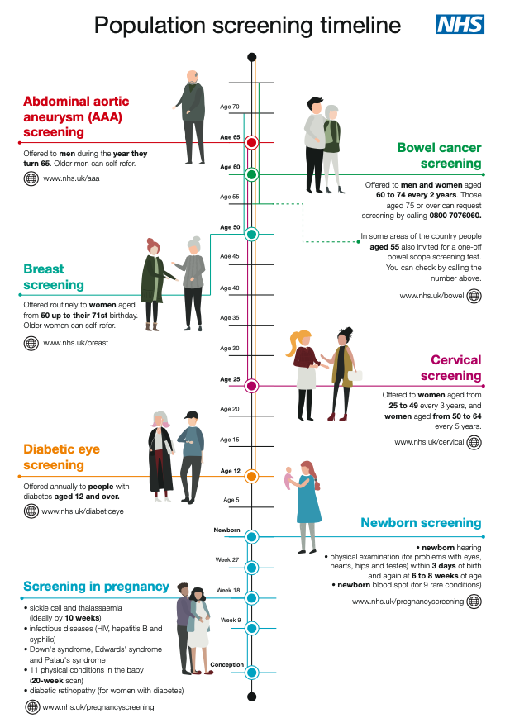
The useful guide to the NHS population screening.

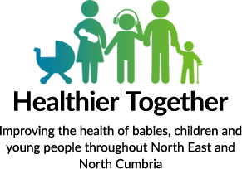
Healthier Together
Trusted and accurate health information for babies, children and young people can be found on this site.
There are dedicated pages for parents, carers and professionals.

https://www.nenc-healthiertogether.nhs.uk

Prescription Prepayment Certificates
If you know you will have to pay for a lot of NHS prescriptions, it may be cheaper to buy a prescription prepayment certificate (PPC) – effectively a prescription "season ticket".

A PPC covers all your NHS prescriptions, including NHS dental prescriptions, no matter how many items you need.

But it does not cover the cost of other health items, such as the provision of wigs and fabric supports, which are only provided through the hospital service.

To check if you are eligible, how to apply for one of the three options, how much they cost and more useful information visit this NHS site.

https://www.nhs.uk/nhs-services/prescriptions-and-pharmacies/save-money-with-a-prescription-prepayment-certificate-ppc/

Menopause Treatment Prepayment Certificates

Also around 400,000 women across England will get better access to menopause support - saving hundreds of pounds and making treatment more accessible.
- Women in England will be able to access cheaper hormone replacement therapy (HRT) for menopause through a new prescription prepayment certificate (PPC).
- To be rolled out from 1 April 2023, the certificate will help around 400,000 women save hundreds of pounds a year, reducing their HRT costs to less than £20 a year.
- Better access to HRT will improve the lives of millions of women in England who suffer from negative symptoms of the menopause.

More information can be found on the following website link.
https://www.gov.uk/government/news/hundreds-of-thousands-of-women-experiencing-menopause-symptoms-to-get-cheaper-hormone-replacement-therapy

Can you identify this regional landmark?

Find the answer on page 6.

Ask the Expert – End of Life Q & As
Death and dying affects us all. The pandemic brought home the challenges carers faced supporting their loved ones through end-of-life care. North Tyneside Carers’ Centre has teamed up with Palliative Care Specialist, GP Dr Kathryn Hall, and the Sage Foundation to record a video in which Dr Hall answers questions from carers about end-of-life care in our region.
We have had amazing support from the Sage Foundation who helped us record this video in their state-of-the-art recording studio and gave so much time and expertise pulling this video together for carers.

We know this can be a difficult and emotional subject, you can watch the video all the way through or click on the question that matters most to you from the list below the video.
To see the video and the list of resources that accompanies it go to: https://www.northtynesidecarers.org.uk/about-us/dying-well/

Health Inequalities Fund
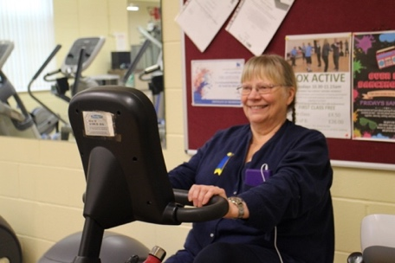
Grants of between £10,000 and £30,000 have been awarded to fourteen Voluntary, Community and Social Enterprise (VCSE) sector organisations. One of the successful applicants was Tyneside and Northumberland MIND.

Healthy body healthy mind: a 12-week programme supports people to improve their physical and mental health and to manage their conditions through gym sessions. Read more about the fund on VODA’S website.
https://voda.org.uk/healthy-body-healthy-mind/

Mental Health Resources
Cumbria Northumberland Tyne & Wear NHS Foundation Trust
Become a member and hear first-hand about the range of mental health services.
https://www.cntw.nhs.uk/membership

Young Minds
A UK charity fighting for children and young people’s mental health.
https://www.youngminds.org.uk

KOOTH is an online mental wellbeing resource for children and young people aged 11-25 years old.
https://www.kooth.com

ChatHealth is a texting service is available for young people aged 11-19 looking for confidential support and advice. The number to text is: 07507 332 532
The school nursing team can be contacted via telephone Monday to Friday 8.30am to 5pm on 0191 643 8251.
https://my.northtyneside.gov.uk/category/1231/childrens-public-health-service-0-19

MIND a mental health charity providing information and support.
https://www.mind.org.uk/information-support/

LAUNCHPAD
Launchpad North Tyneside is an independent user-led group by and for people who currently or in the past have used mental health services.
https://launchpadnt.wordpress.com

Did you identify this?

Answer: Wallsend Park
Thank you to Sam Stephenson for the image.

Working Well North Tyneside
From accessing the latest jobs through to mental health support, Working Well North Tyneside brings vital services together into one location for the first time to help support people into work.
The new hub is breathing life into a vacant store in North Shield’s Beacon Centre and the central location means it’s accessible via public transport, cars and on foot for local residents.
The one-stop-shop will make it easier for people to access employment and skills services, view the latest jobs on the market and receive support around housing, finance, debt, and physical and mental health.
Specialist teams will be based at the hub and partners from across the region will be offering their services including the NHS, Age UK, Citizens Advice, National Careers Service and the community and voluntary service. More information can be found on this link: https://www.skillsnorthtyneside.org.uk/support/workingwell/

North Tyneside Patient Forum Highlights
NHS North East & North Cumbria-North Tyneside Place Patient Forum is strong, robust and acts as a critical friend. Members are encouraged to challenge and debate throughout all engagement processes. The Patient Forum was established 10 years ago and brings together residents with an interest in health and services for the borough.

During the year April 2022 and March 2023 members were busy with lots of initiatives and meetings.

The main Patient Forum meets every two months and the six meetings included discussions on the 111 service, primary care developments and ongoing research on safe transition from hospitals to care homes. Average attendance to meetings was 24 members.

The comprehensive presentation on how the 111 service works for patients was well received by members and gave an understanding of the demand and challenges the service faces. More information can be found here.
https://www.neas.nhs.uk/our-services/nhs-111.aspx

Most recently members have visited two health hubs in the borough; North Shields and the North West to see first-hand how additional staff roles in primary care such as; mental health support workers and nurse practitioners are in place for the benefits of patients.

Working Groups

Communications; this group meets monthly and the main aim is to produce a quarterly newsletter for residents.
End of Life; members have influenced the Care of the Dying document, Coroners expected deaths leaflets, bereavement support and the end of life care strategy.
Mental Health; there have been service visits, dementia friendly training and involvement with the transformation programme.

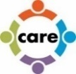
Future Care; historically members have had the opportunity to visit the Northumbria Hospital in Cramlington to see how urgent care works for patients, created falls prevention information bookmarks and posters and had discussions about the proposed Backworth Ageing Well Village.
Innovations; most recently members have prioritised areas they feel would benefit from information videos, healthy eating and foodbanks are the current topics. This group also has the opportunity to inform and sometimes test out new initiatives such as the Livi online GP appointments service.

Task and Finish Groups
Talking Therapies; members revised patient letters.

Equally Well Implementation Plan; members supported the Plan and fed back on the content. The North Tyneside Plan aims to have real outcomes to address health inequalities.

Waiting Well; this proposed initiative for patients waiting for surgery such as a hip replacement would be supported with ways of getting fit for their procedure. Members influenced the draft publicity material.

This newsletter has been produced quarterly by members of the North Tyneside Patient Forum Communications Working Group.

If you like the sound of the Patient Forum and would be interested in being part of it please contact; Michele Spencer michele@chcfnorthtyneside.org.uk for more information.

