Patient online services.
You can access online services via the following Apps

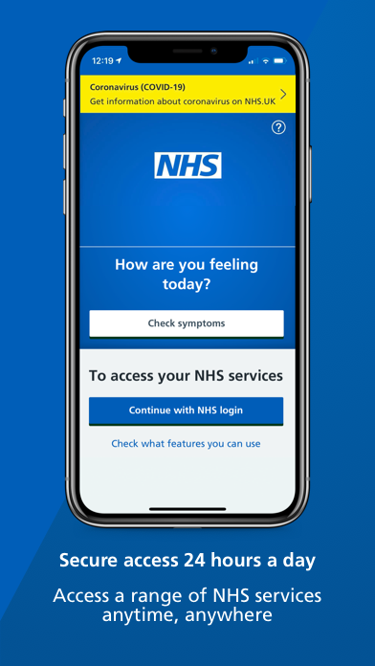
https://www.nhs.uk/apps-library/nhs-app/ https://www.patientaccess.com/
NHS App will need to be downloaded to your For Patient Access you go on to the website
mobile phone then you will need to register you can also download the Patient Access App
your contact details to use. To your mobile phone.
Please watch the video on the website

Patient Access – Go onto the website Patient Access
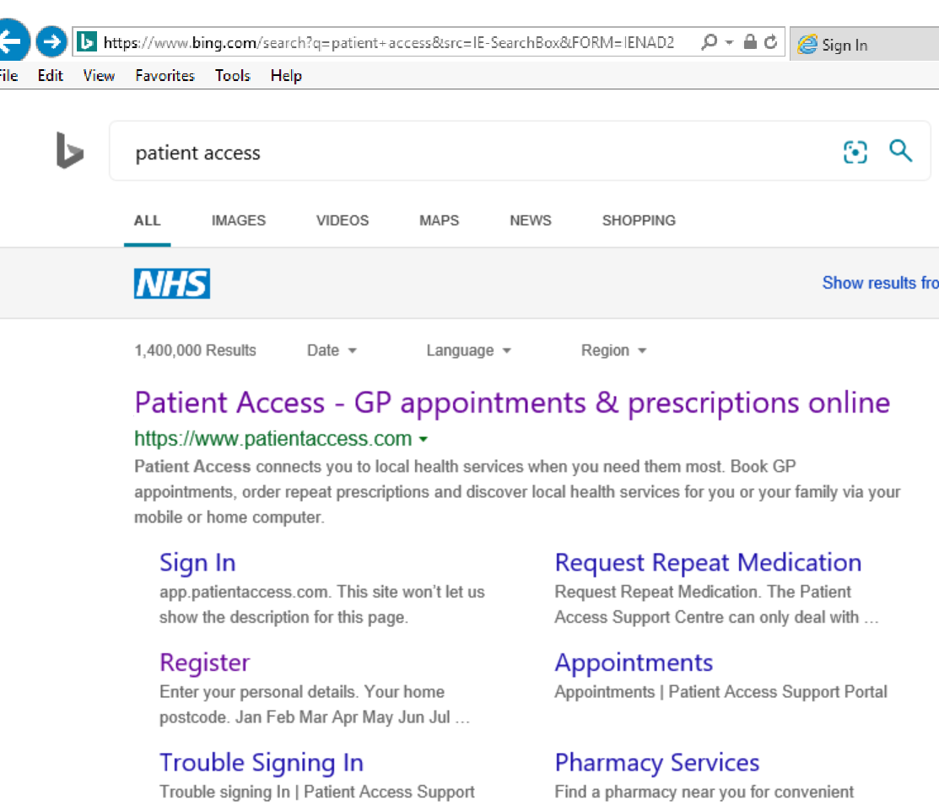
Once you have opened Patient Access in the top left hand corner there is an option to Register.

Click on the register button and then fill in all of your personal details
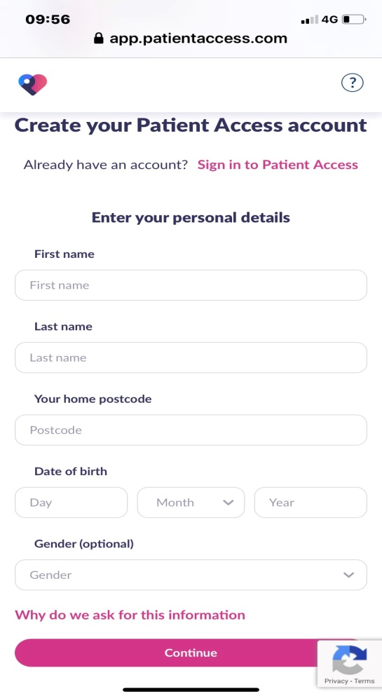
Click on continue it will take you to “Create your Patient Access Account page”
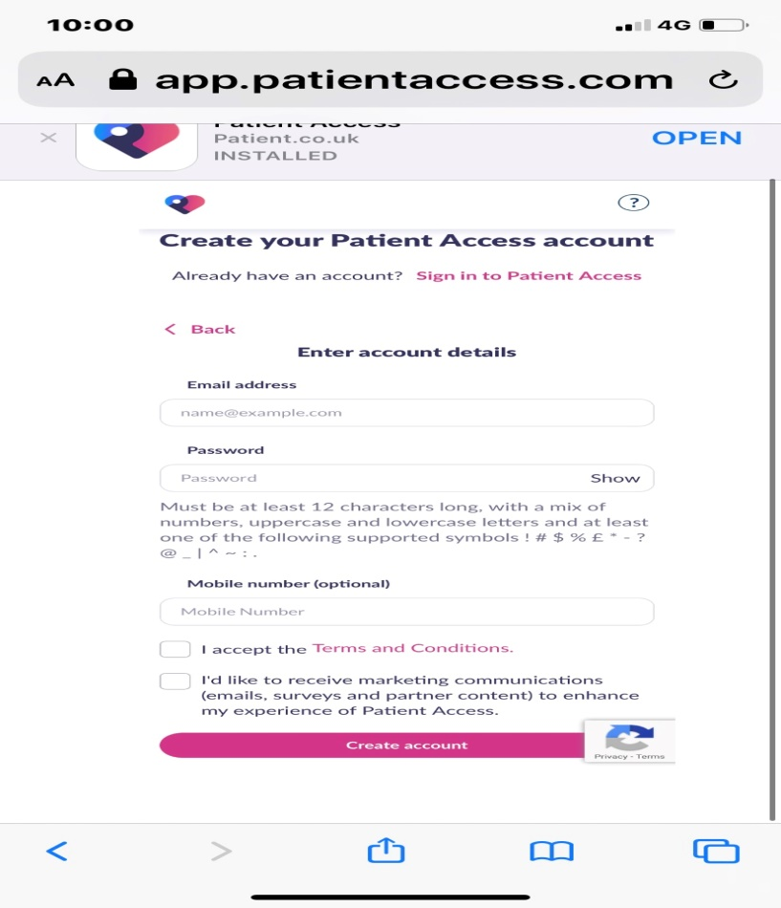
Make sure your password is 12 letters long, have a capital letter a number and a symbol. For example “Bewickemedical1#”
Then click create account

Your Patient Access account has been successfully created.
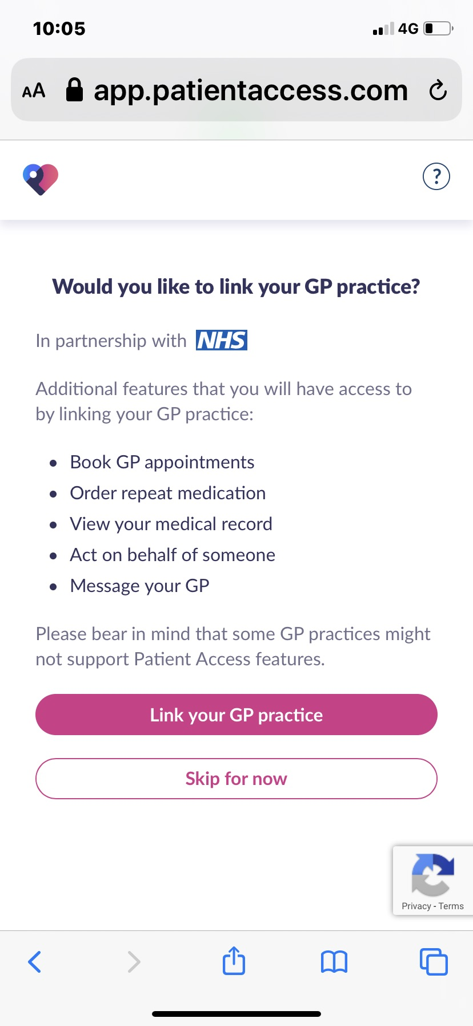
Click on link your GP Practice

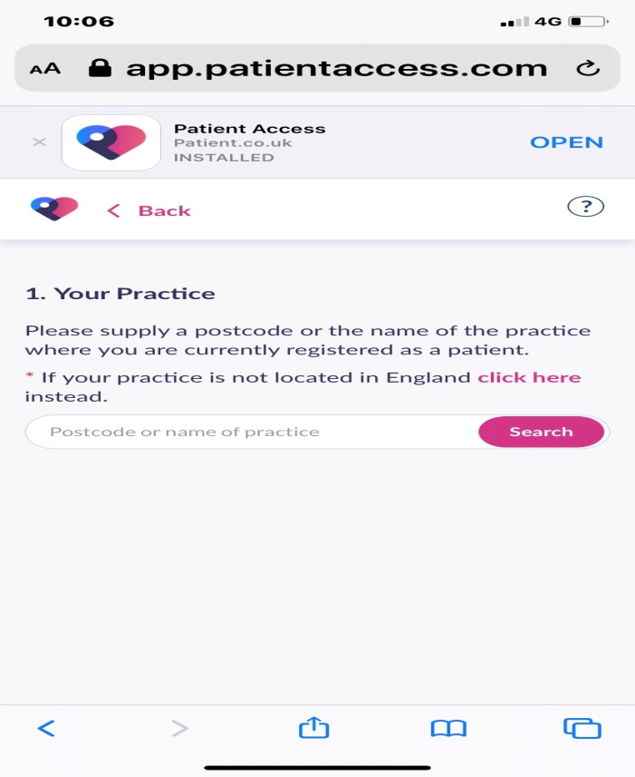
Type in Bewicke Medical Centre or
NE28 0AD

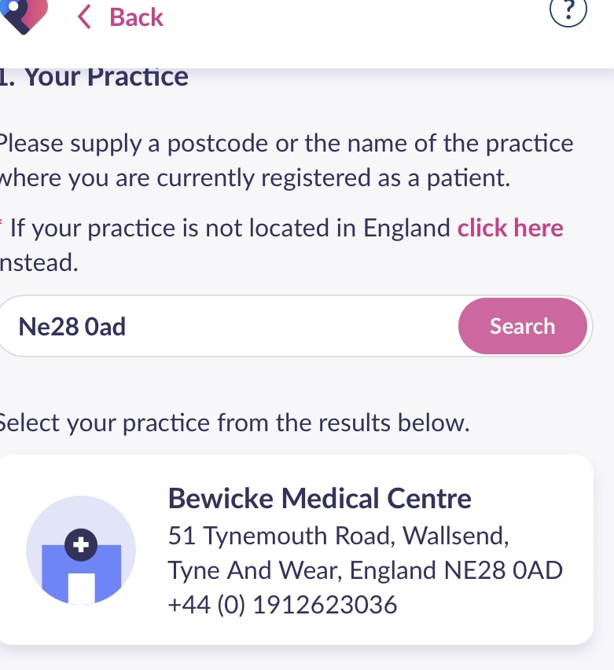

Have you received a registration letter from your practice?
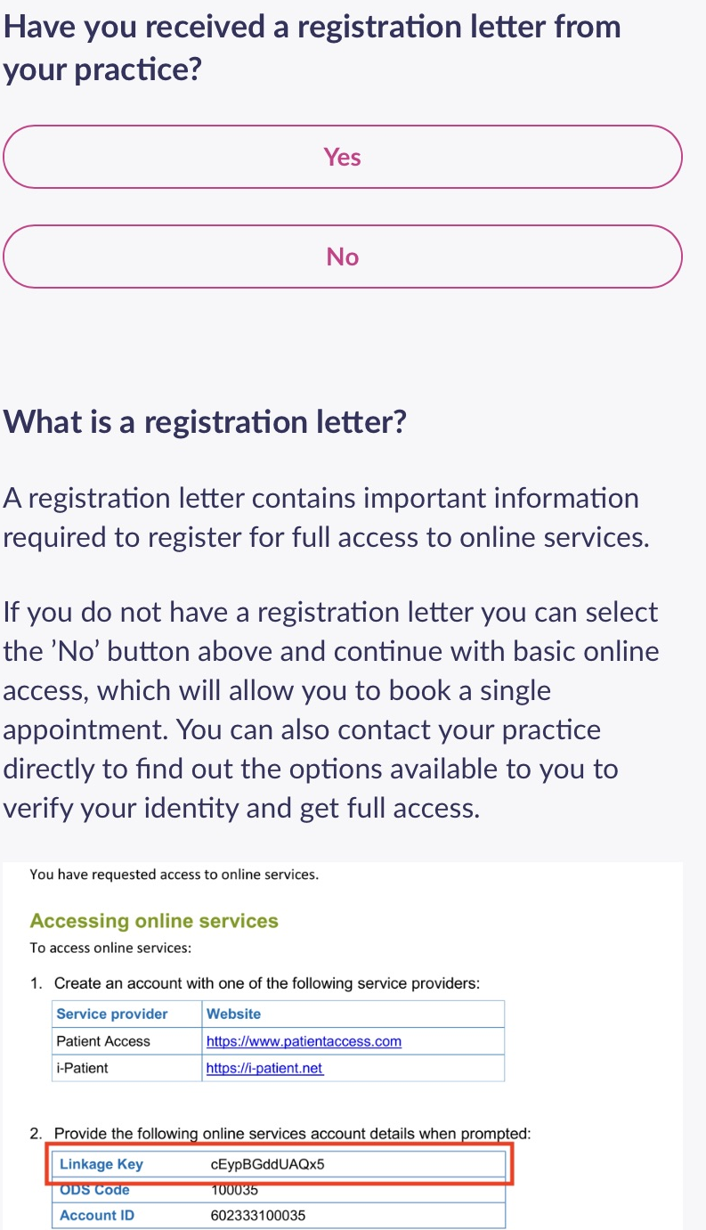
Make sure you received our email, if you have then click yes if not you will have to contact the surgery so we can get a registration letter sent to you.
Linkage Key and Account ID shown.

If you have received the registration letter click “YES”
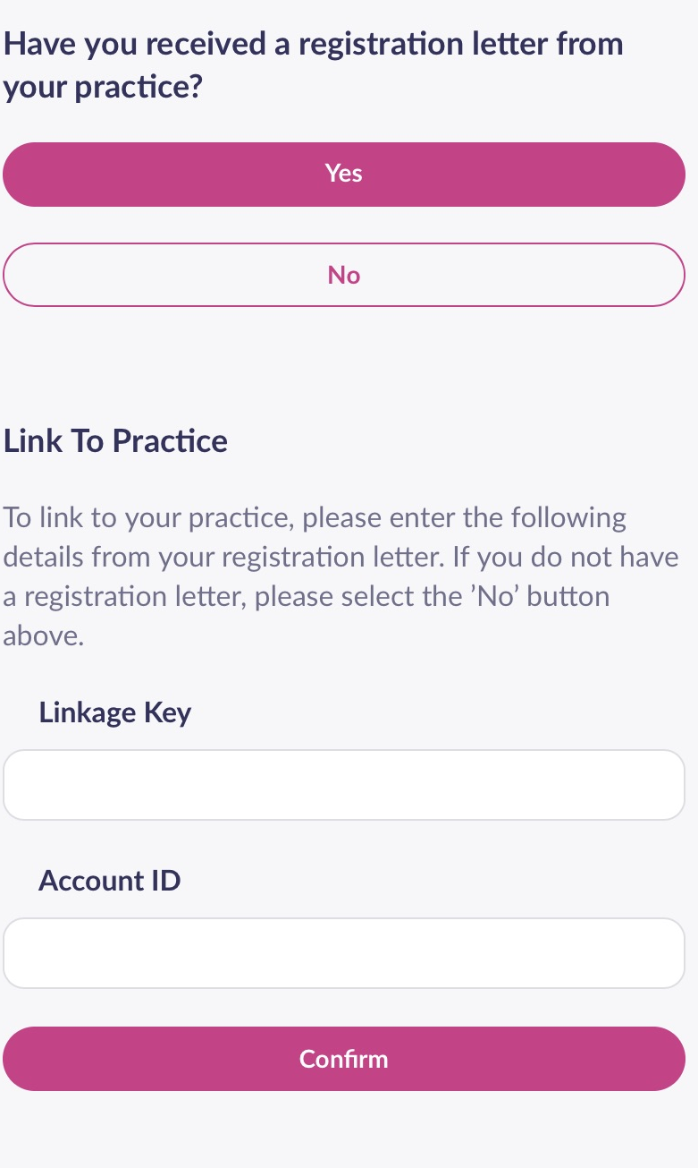

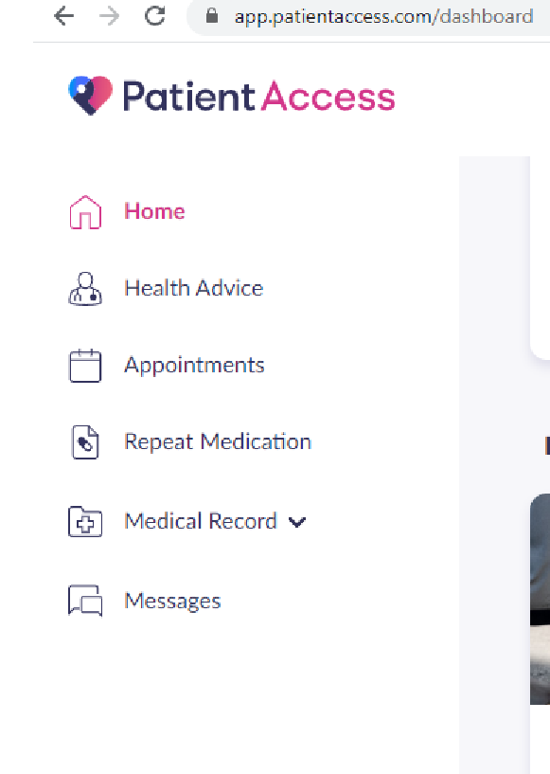
When you click on the Repeat Medication Icon the screen will change. Click on the add next to the medication you are wanting to order and then click “Request Medication”. This will then get sent to the GP. It will then take 2 working days for this to be sent to your nominated pharmacy.
When you are logged into patient access the screen will look like this. To book appointment click on the appointments icon to order repeat medication click on the repeat medication icon.
At the very bottom of the email, it will have the linkage key and account ID which will need to be entered here then click confirm.

